Lab: Building Autonomous Agents in CoPilot Studio.
By Kevin O’Bryan
Lab Guide

The Lab
Discover how to build an autonomous agent by using Microsoft Copilot Studio to transform routine tasks into intelligent, automated workflows. This lab introduces the fundamental concepts of autonomous agent capabilities, explores real-world applications, and provides exercises to help you practice building and deploying an agent effectively.

This document
This document’s purpose is to assist with building an autonomous agent to perform generative and automation tasks that require dynamic variables that traditional pipelines cannot provide. Autonomous agents can work for a variety of tasks, but for this document, I will be using the example of device Procurement.

aPPLICATIONS
Throughout this lab, we will be using the following M365 applications:
- Dataverse in PowerApps
- CoPilot Studio
- Power Automate

Getting started in powerapps

Log into PowerApps

In the top right corner, select Environment and make sure you select an environment that isn’t yourOrganization’s default. (Ask Kevin for help if you need to create an environment).

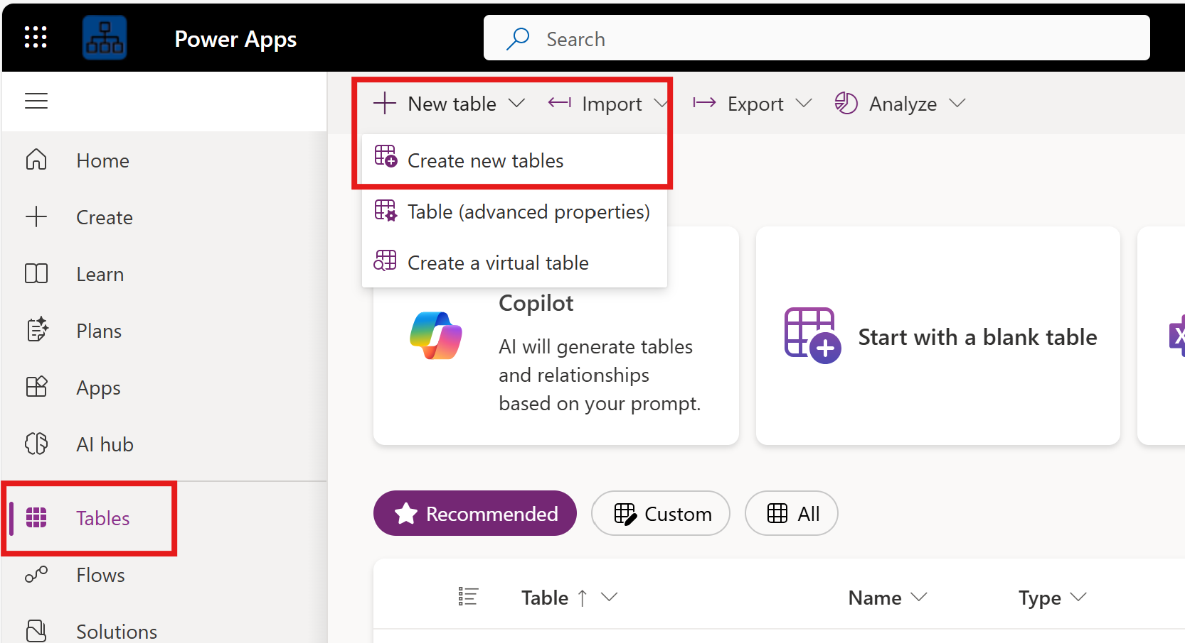

Select Tables in the lefthand side.

Select New Table, Create new tables

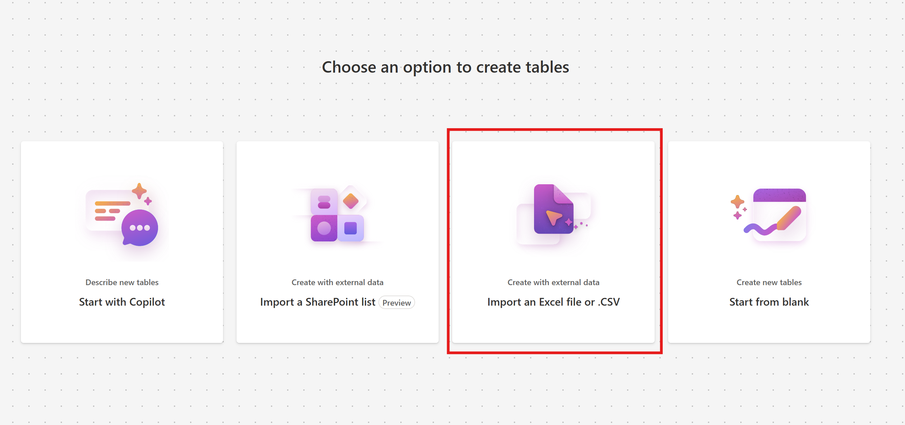

Download the Surface_Inventory_Updated.xlsx and upload it using the Import an Excel file or .CSV option

Once the file uploads, select save and exit in the top right.

Go back to Tables and you should see a new table in the list labeled Device Inventory.

Repeat steps 4.4-4.7 for Surface_Assigned_Assests. This table should be labeled something similar to Device Assignments.
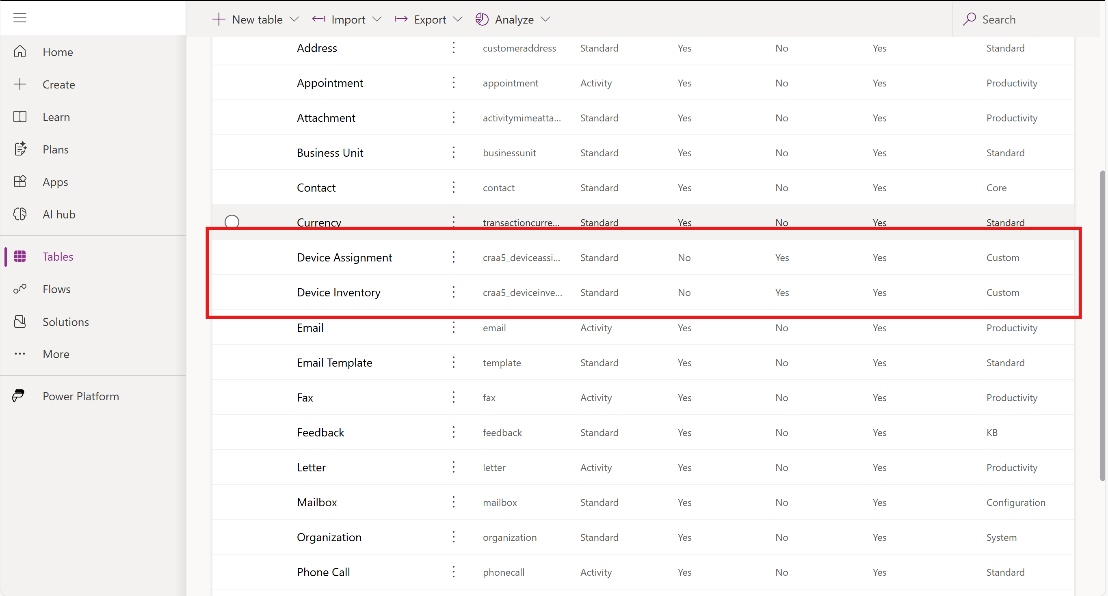

Copliot studio – Creating the Agent

Log into CoPilot Studio

Select your Environment that you created your Dataverse table in in the top right corner.

Select Agents on the lefthand side and Create a new Agent.
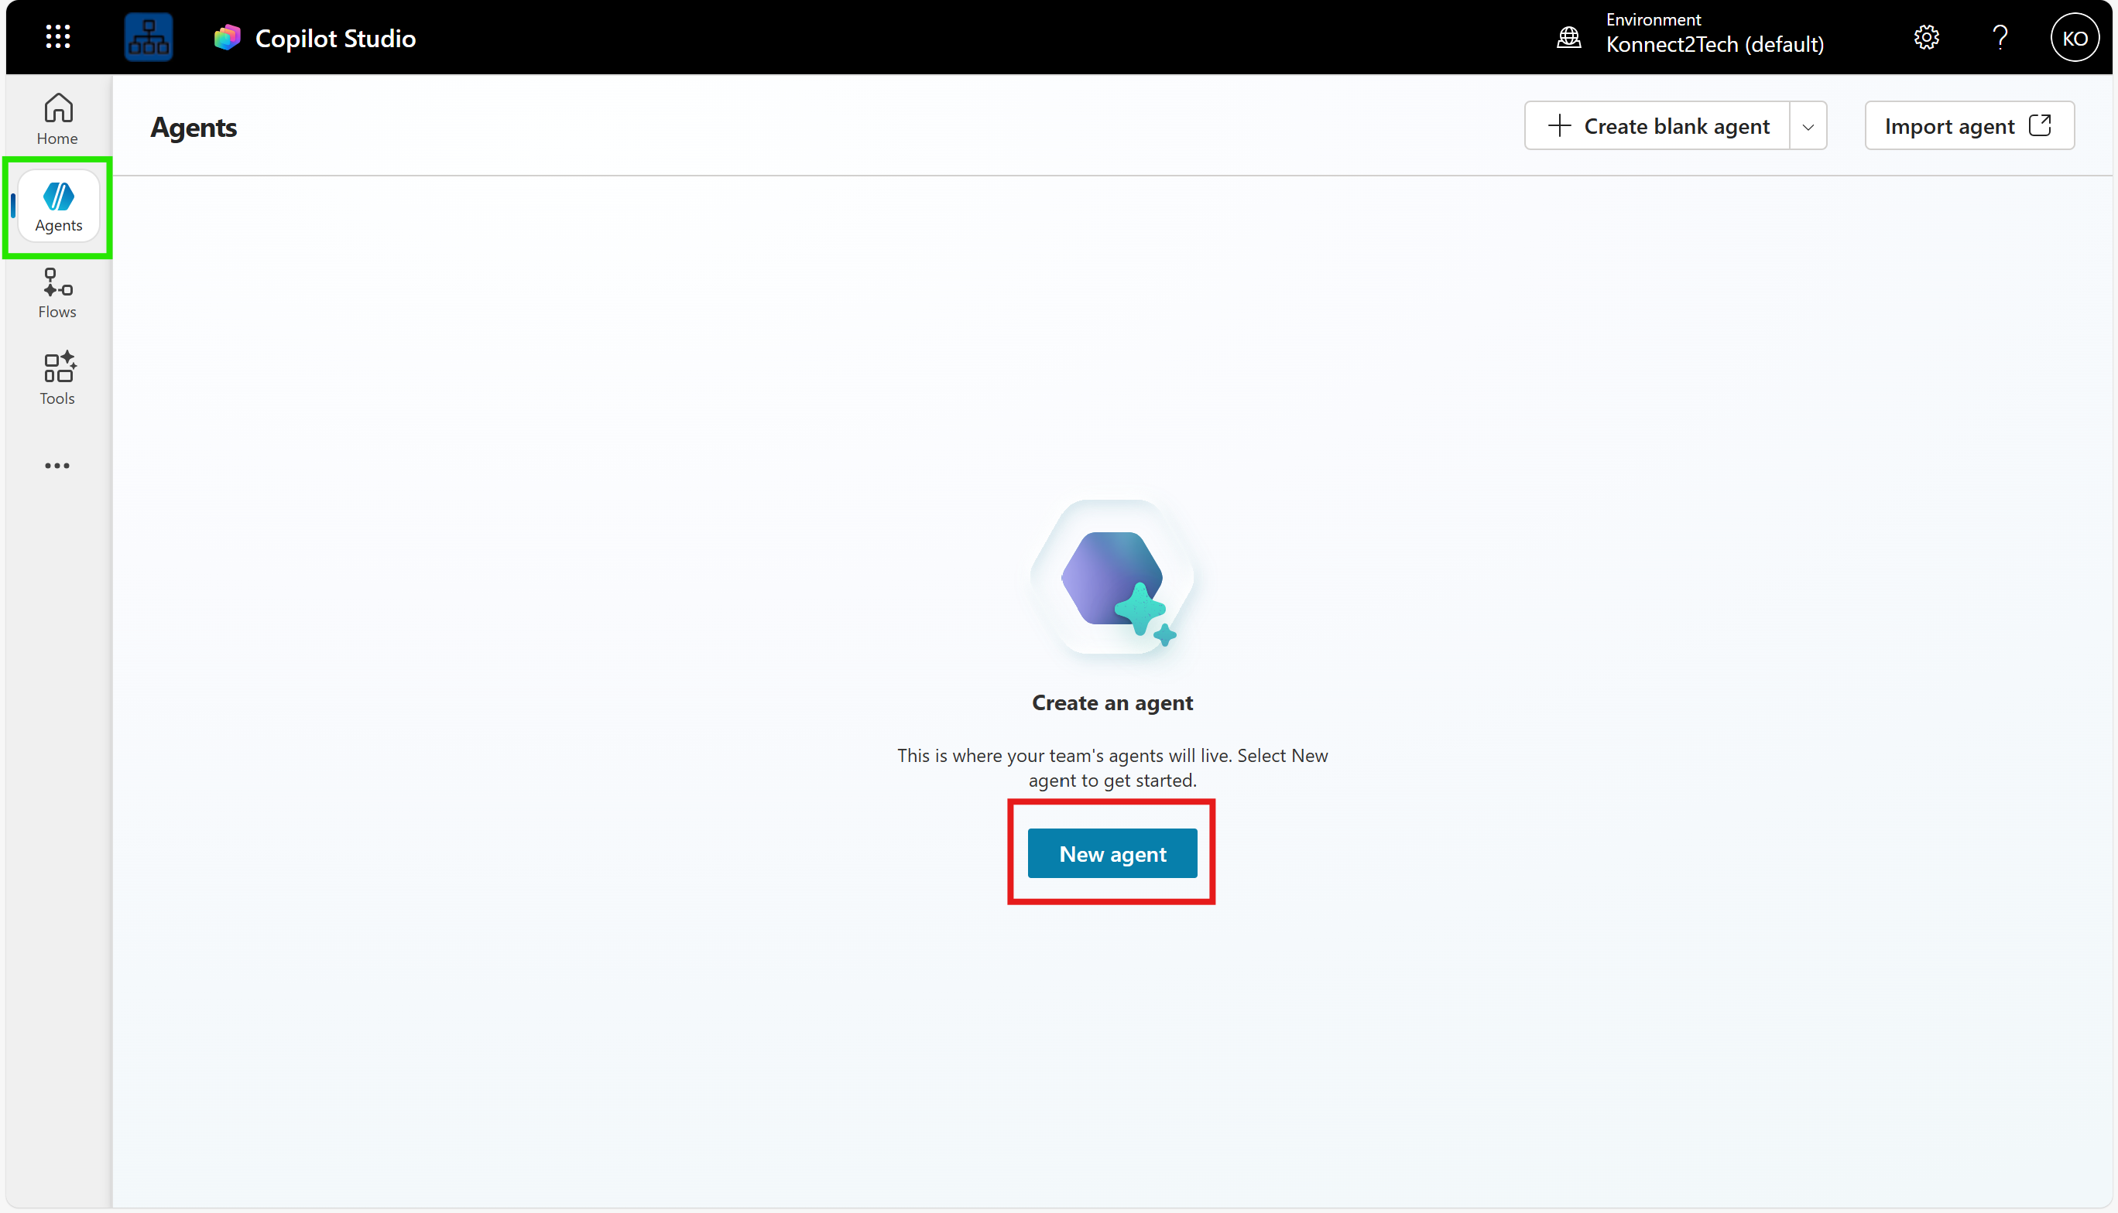

Select Skip to Configure.

Set the Name, Description, and Instructions

Name the Agent Autonomous Device Procurement Agent.

Set the description as: This agent assists with the onboarding related task of new device procurement for employees.

NOTE: THIS IS THE MOST IMPORTANT SECTION FOR THE AGENT.

The General instructions is what the autonomous agent will ground itself with to make sure the generative and orchestration is handled how we want it to. Without detailed general instructions, the agent will hallucinate more frequently and we will not get the actions we want.

Enter the following for your General Instructions:
You will receive a request to procure a device for a new employee.
1. lookup the user a. You will take the name of the employee needing a new computer. This information will be concluded from the email received from the trigger "When a new procurement email arrives". Make sure to use the email address. b. You will select a device based on the user's title running the Tool "Lookup User".
2. Inventory check and assign the device
a. From the list of options in the knowledge source "Device Inventory", check the "Assigned Count" and "Inventory Count" columns.
b. If the "Assigned Count" is less than the "Inventory Count", the device can be assigned.
c. Choose a device that is best fit for the user based on their title.
3. Procure the device
a. Run the "Procure new device" tool to submit the device for procurement.
4. Get laptop details
a. use the knowledge source "Microsoft Surface Laptop Devices' to grab the details about the new employee's device like display size, RAM, memory, storage, and battery life.
5. Send an email
a. use the "Send confirmation email" action to send an email to the new employee to confirm the new procurement with all the submission details in the body and the details captured from the "Microsoft Surface Laptop Devices" knowledge search.
b. This email must be formatted nicely and professionally.

Create the Agent when finished.

Setting the Agent’s Knowledge Base.

Once the Agent is built, select it and scroll down to the Knowledge section.

Select Add Knowledge

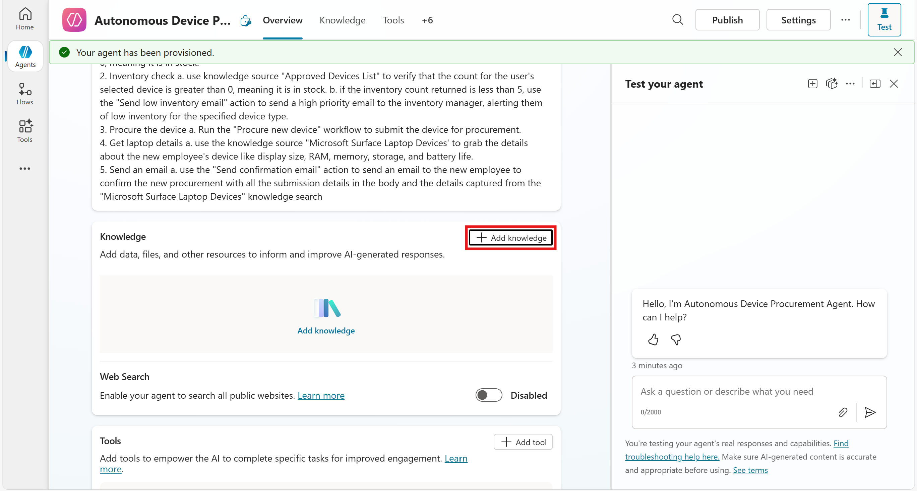

Select Public Websites

Add www.microsoft.com as the Link

Add the Name for the Knowledge Base as Microsoft Surface Laptop Devices, and this for the description: This knowledge source searches information on the web found in https://www.microsoft.com website to get details for the employee's device like Display Size, Ram, Memory, Storage, and Battery Life.

Add another Knowledge Base like in step 5.5.2 and select Dataverse.

Select Device Inventory and add it.

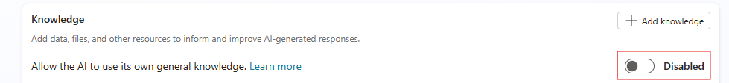
Turn off the “Allow the AI to use its own general knowledge” radio button, so the agent doesn’t use knowledge sources outside of what you deem acceptable.

Setting up the Tools (Workflows)

Under Tools, select Add Tool

Select Office 365 Outlook
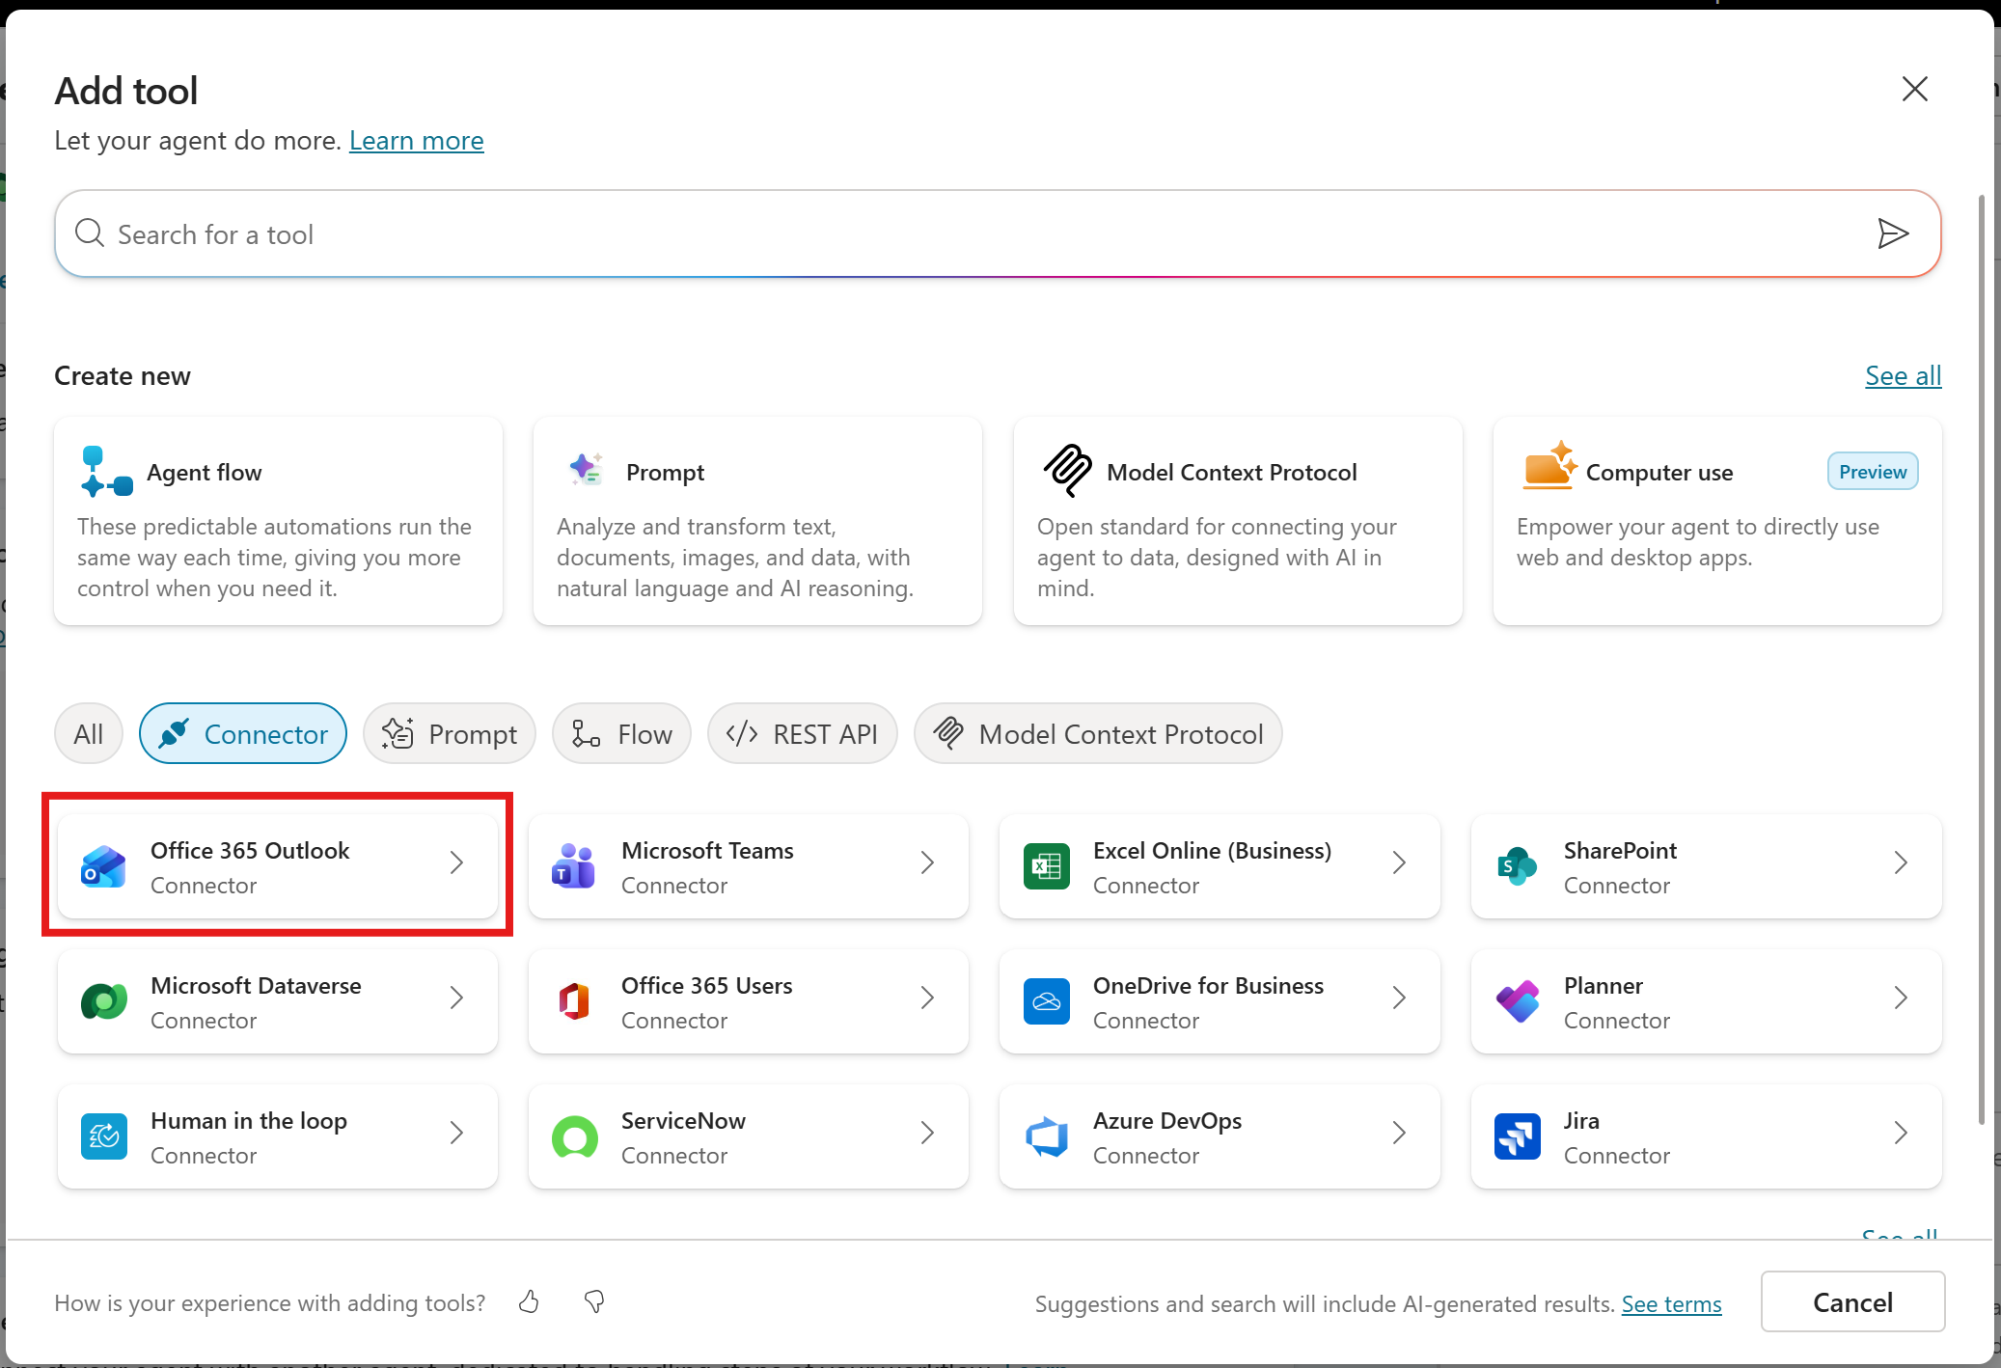

Select Send an email (V2). If you do not currently have a connector setup, create a new one.
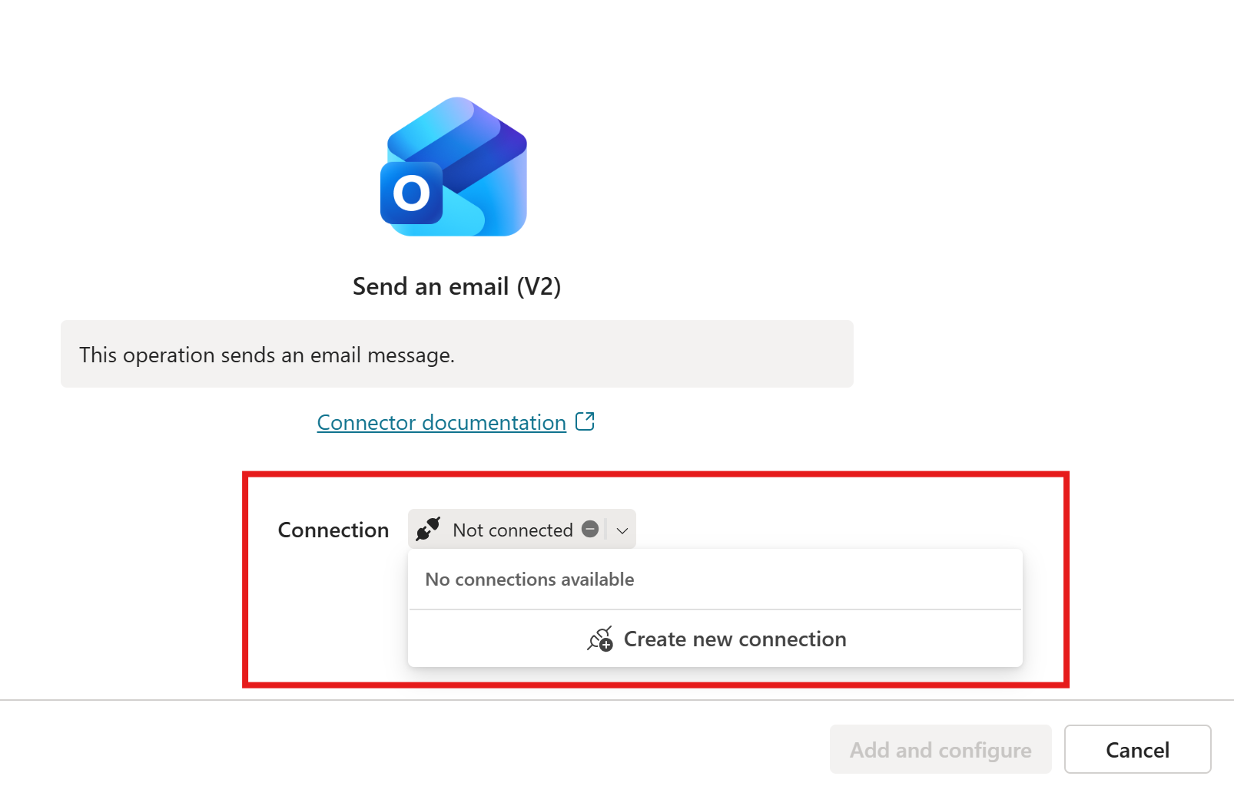

Select Add and configure

Name the Tool Send Confirmation Email, add the description: This operation sends an email message to the user once the device has been procured and researched in step 4.

Under Inputs, change the Subject to custom value and enter the following: DO NOT REPLY: Device Procurement Notification
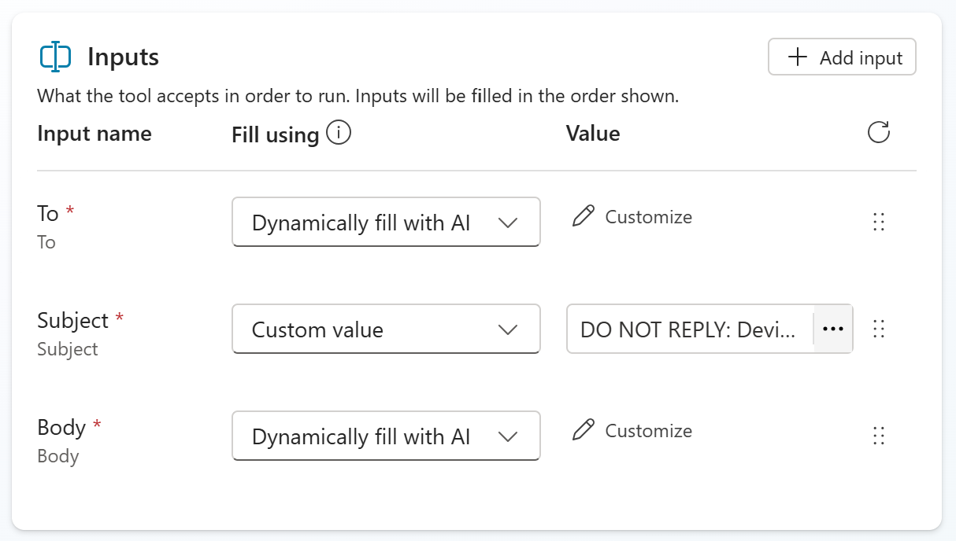

Save the Tool

Add another Tool and select Agent Flow

Select the When an agent calls the flow step and set two inputs as Employee and Device
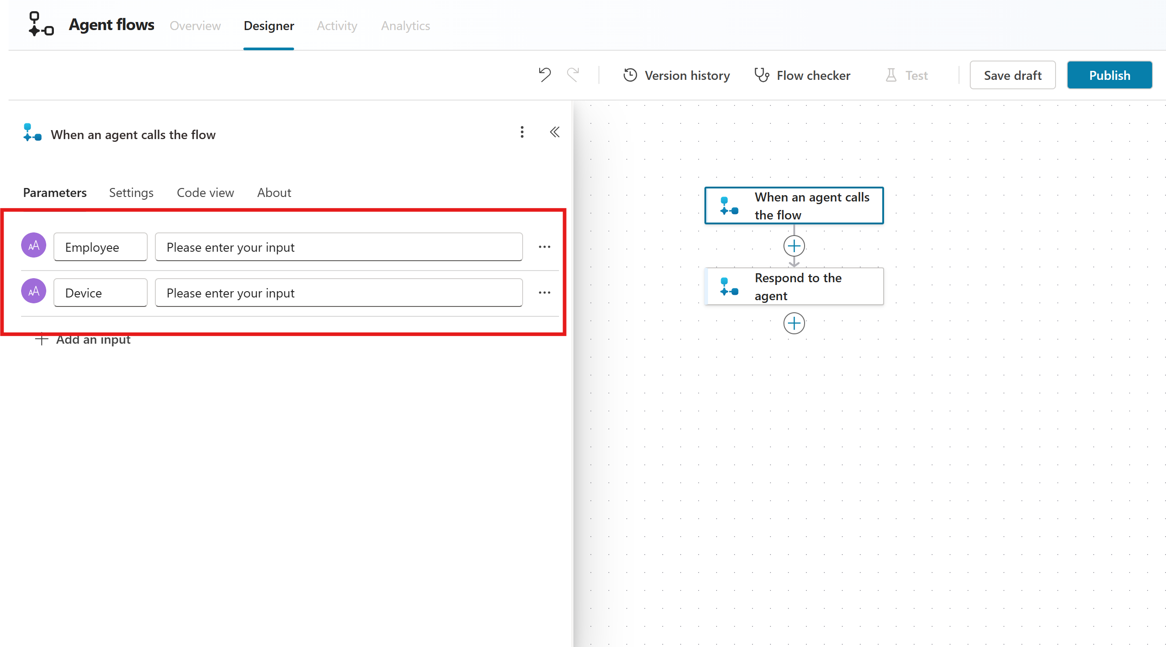

Add the Search for Users (V2) action for the second step

Add the Employee Dynamic Value from the When an agent calls the flow step as the Search Term.
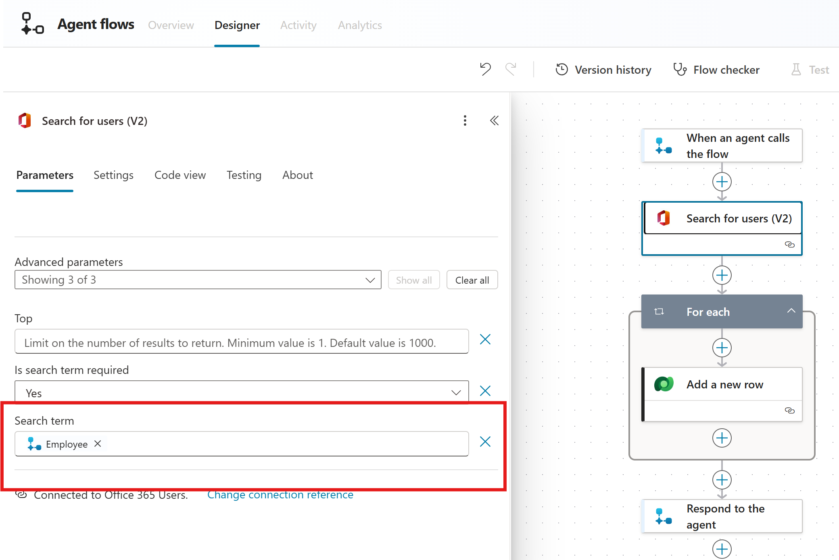

Add the Dataverse action Add a new row.

Set the Assigned User value to the Dynamic value for the Display Name.

Set the Device Assignment value to the function utcNow()

Set the Device Name value to the dynamic value of the Device Dynamic value from the When an agent calls the flow step as the Search Term
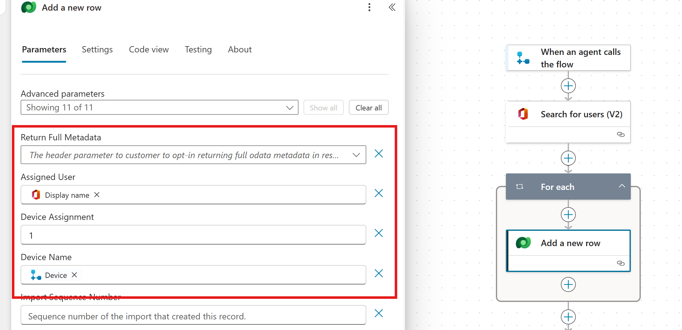

Publish the flow in the top right corner.

The name will update to Untitled in the right-hand corner. Double click it and update it to Procure new device

Go back to your Agent go to Tools and add a tool.

Select Flow in the filter and select Procure new device.
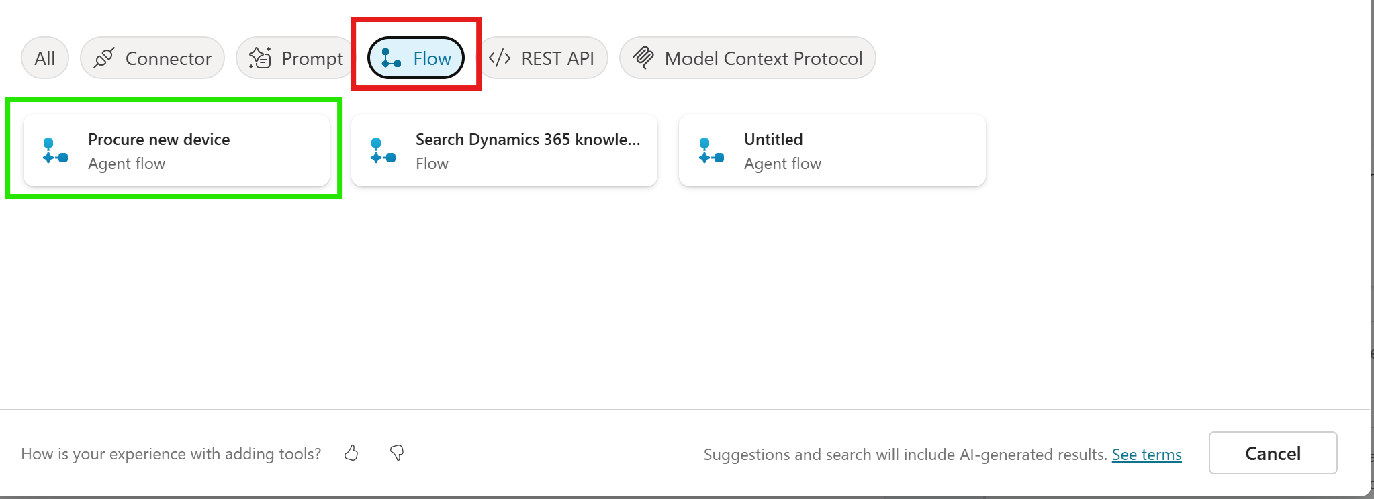

Create a new flow repeating step 5.7.8.

Select the When an agent calls the flow step and add the input Employee

Add the Get User Profile (V2) action for the second step

Add the Employee Dynamic Value from the When an agent calls the flow step as the Search Term.
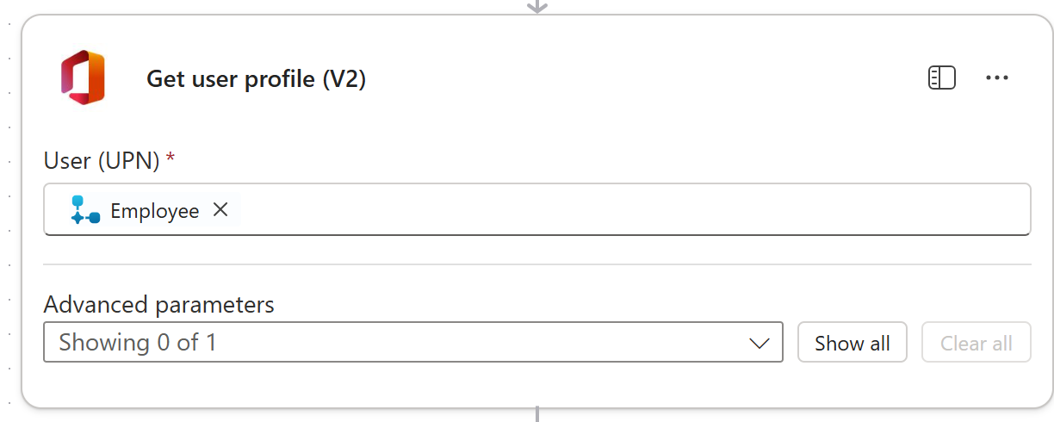

Publish the flow in the top right corner.

The name will update to Untitled in the right-hand corner. Double click it and update it to Lookup User

Go back to your Agent go to Tools and add a tool.

Select Flow in the filter and select Lookup User.

Setting up the Trigger

Under Triggers select add trigger
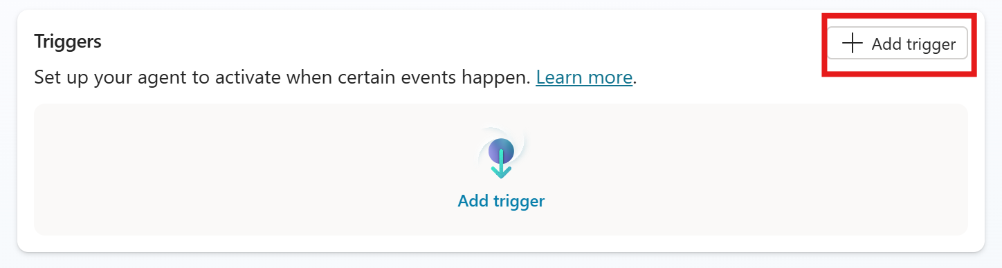

Select the When an email is received (v3) trigger
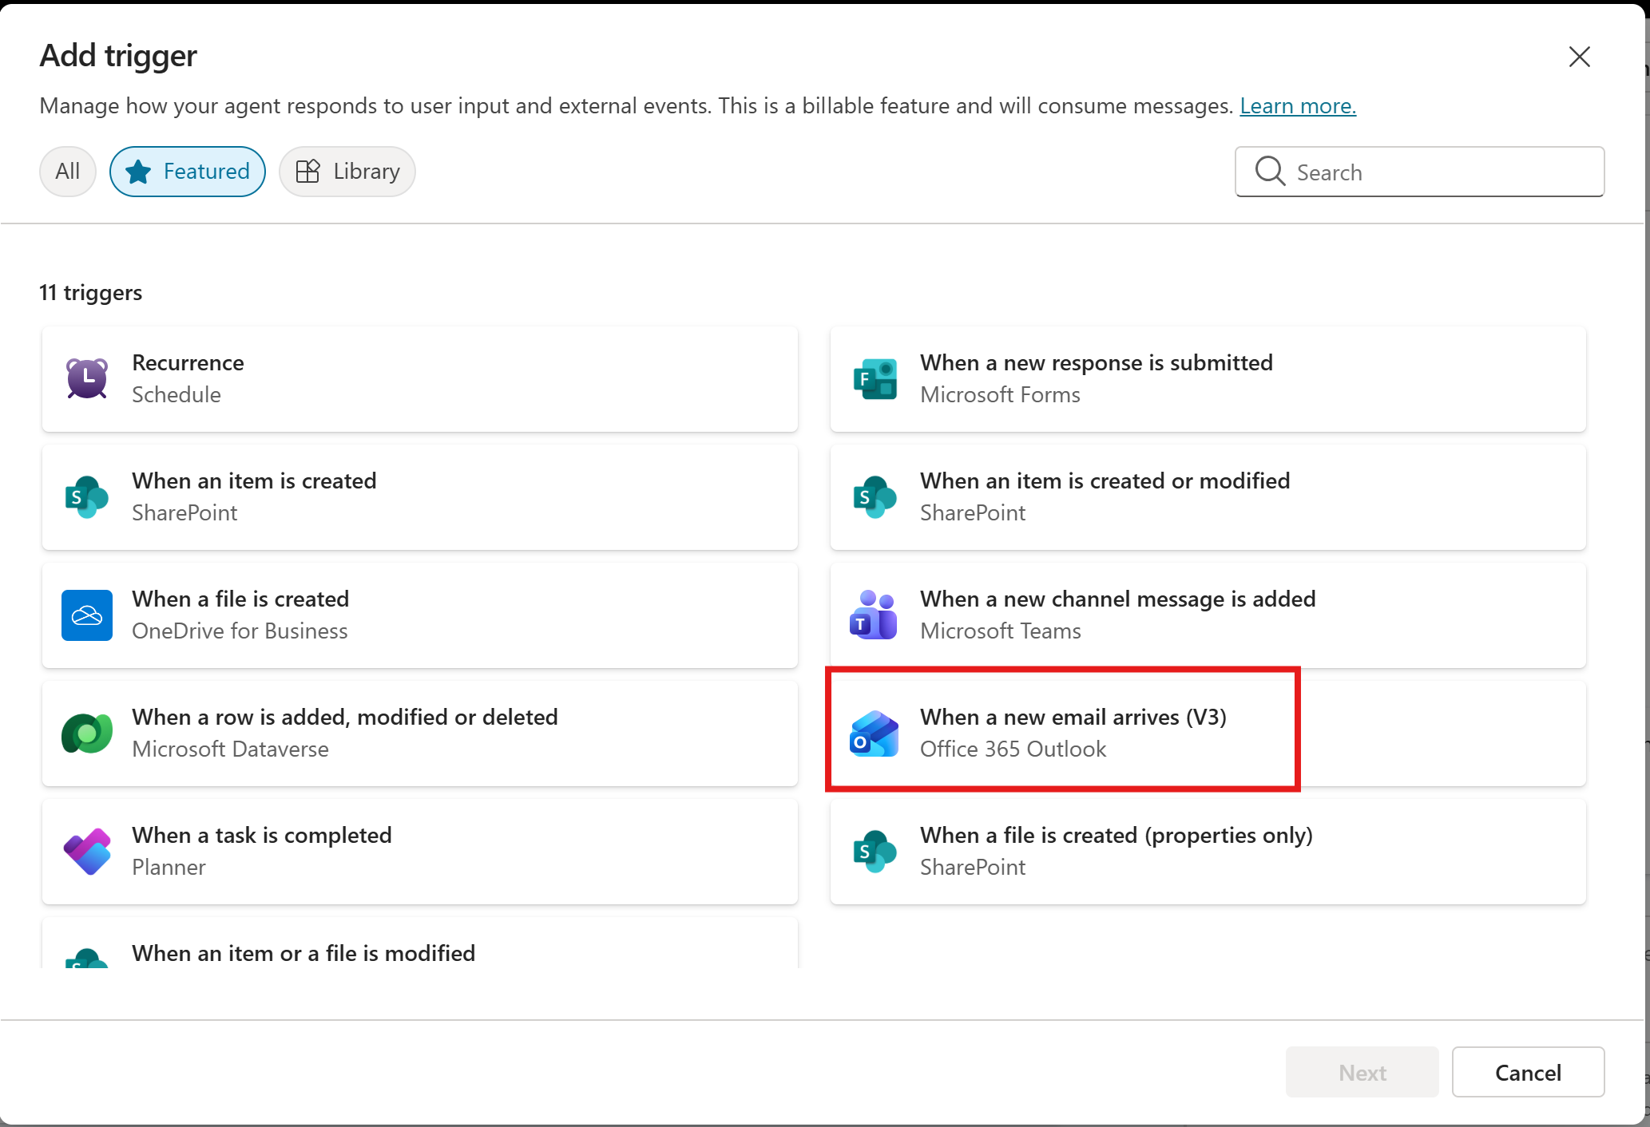

Set the name to When a new procurement email arrives

Set the Subject Filter to New Device Request

Save and create the trigger.

Turn on Deep Thinking for AI

Go to settings in the top right corner.

Under Orchestration, make sure the Deep reasoning (preview) is turned on.
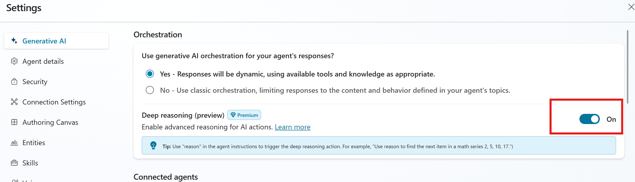

Publish the Agent in the top right corner.

Send yourself an email with the subject New Device Request and see how the agent does.

